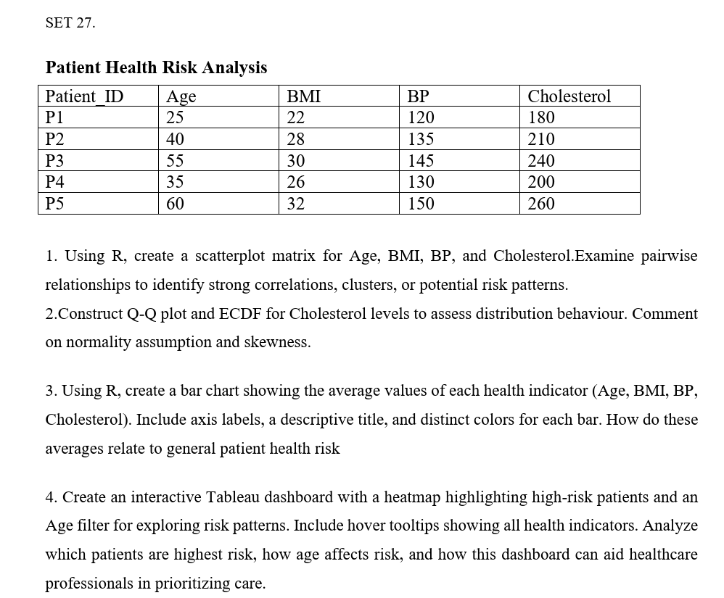

SET 27 – Patient Health Risk Analysis

Question 1: Scatterplot Matrix

Aim
To create a scatterplot matrix for Age, BMI, BP, and Cholesterol using R to identify pairwise relationships and potential health risk patterns.

Code (R)
Question 1 – R Code
# Patient Health Risk Analysis

patient <- data.frame(
Patient_ID = c("P1", "P2", "P3", "P4", "P5"),
Age = c(25, 40, 55, 35, 60),
BMI = c(22, 28, 30, 26, 32),
BP = c(120, 135, 145, 130, 150),
Cholesterol = c(180, 210, 240, 200, 260)
)

# Scatterplot Matrix
pairs(patient[, c("Age", "BMI", "BP", "Cholesterol")],
main = "Scatterplot Matrix of Patient Health Indicators",
col = "blue",
pch = 19)

# Correlation Matrix
cor(patient[, c("Age", "BMI", "BP", "Cholesterol")])

Output:
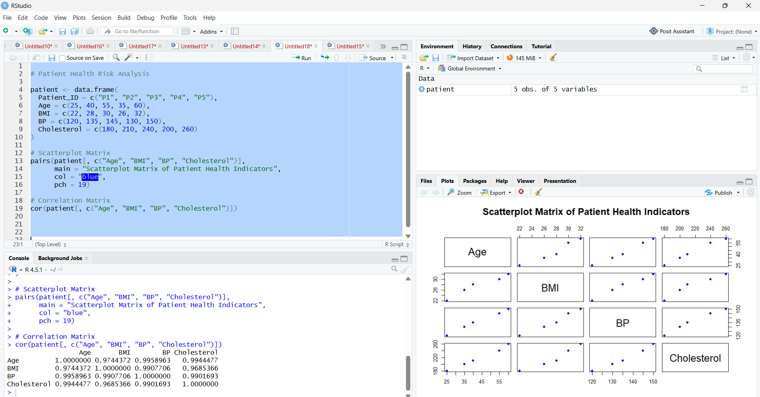

Result
The scatterplot matrix displays the pairwise relationships among Age, BMI, BP, and Cholesterol. The indicators show generally positive relationships, particularly Age with BP and Cholesterol. Patient P5 has the highest values for all four indicators, while P1 has the lowest. These patterns may indicate increasing health risks, but clinical assessment is required to determine individual risk.

Question 2: Q-Q Plot and ECDF for Cholesterol

Aim
To construct a Q-Q plot and an Empirical Cumulative Distribution Function (ECDF) for cholesterol levels and assess their distribution, normality, and skewness.

Code (R)
Question 2 – R Code
# Cholesterol Data
cholesterol <- c(180, 210, 240, 200, 260)

# Q-Q Plot
qqnorm(cholesterol,
main = "Q-Q Plot of Cholesterol Levels",
col = "blue",
pch = 19)

qqline(cholesterol, col = "red", lwd = 2)

# ECDF Plot
plot(ecdf(cholesterol),
main = "ECDF of Cholesterol Levels",
xlab = "Cholesterol",
ylab = "Cumulative Probability",
col = "blue",
lwd = 2)

grid()

Output:

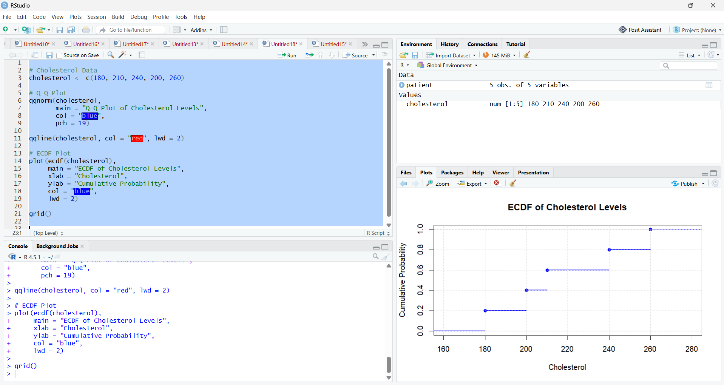

Result
The Q-Q plot compares the cholesterol values with theoretical normal quantiles. Points approximately following the reference line suggest compatibility with a normal distribution, although five observations are insufficient to confirm normality. The ECDF increases from 0 to 1 as cholesterol levels increase from 180 to 260. The data have a mean of 218 and a median of 210. The small sample does not provide strong evidence of skewness; more observations are needed for a reliable conclusion.

Question 3: Bar Chart of Average Health Indicators

Aim
To calculate the average values of Age, BMI, BP, and Cholesterol and display them using a bar chart with distinct colors, axis labels, and a descriptive title.

Code (R)
Question 3 – R Code
# Patient Health Data
patient <- data.frame(
Age = c(25, 40, 55, 35, 60),
BMI = c(22, 28, 30, 26, 32),
BP = c(120, 135, 145, 130, 150),
Cholesterol = c(180, 210, 240, 200, 260)
)

# Calculate Average Values
averages <- colMeans(patient)

print(averages)

# Bar Chart
barplot(averages,
main = "Average Patient Health Indicators",
xlab = "Health Indicators",
ylab = "Average Value",
col = c("skyblue", "orange", "green", "tomato"),
border = "black",
ylim = c(0, 250),
las = 1)

grid(nx = NA, ny = NULL)

Output:

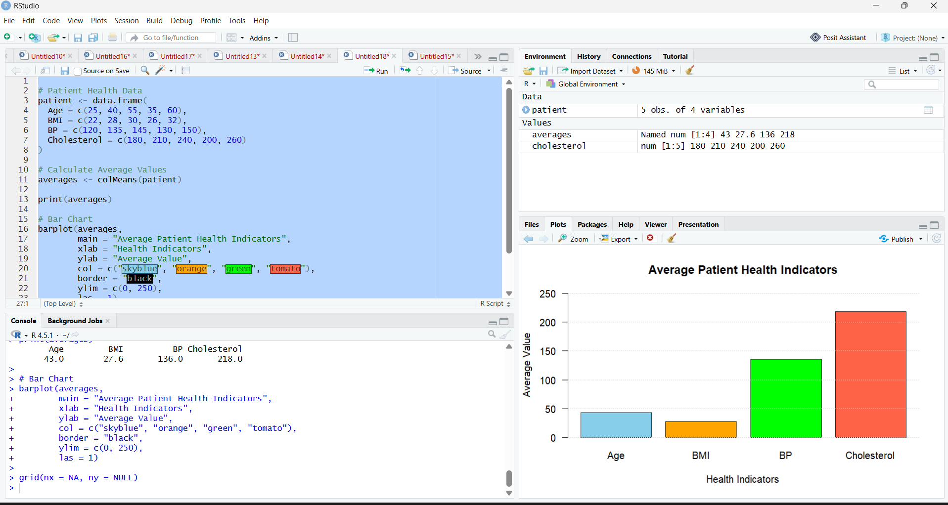

Result:

The bar chart compares the average values of the four indicators. BMI, BP, and cholesterol use different measurement scales, so their bar heights should not be compared directly to determine risk. The average BMI falls within the overweight category, while the average BP and cholesterol levels warrant further assessment. Individual measurements and appropriate clinical guidelines are needed to evaluate patient health risk.
Question 4: Interactive Tableau Dashboard for Patient Health Risk Analysis

Aim
To create an interactive Tableau dashboard using a heatmap, an Age filter, and hover tooltips to identify patients with potentially elevated health indicators and support healthcare prioritization.
Output:
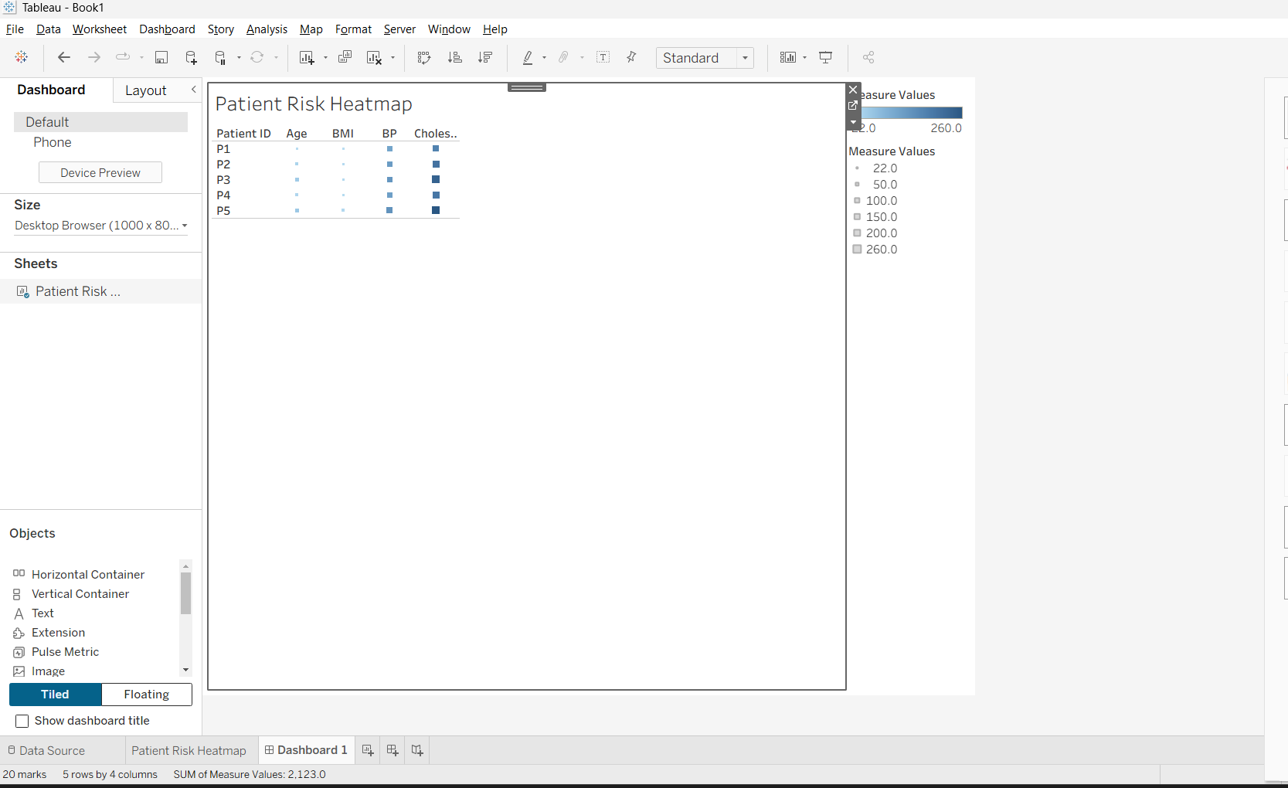

Result
The interactive Tableau dashboard displays the health indicators of all five patients in a heatmap and allows users to filter patients by age.

